Day8 - 9/21 CAP theorem

* Distributed system – nodes are distributed and communicate over a network Consistency, Availability, Partitioning tolerance
* **C**: all reads get you the latest write
* **A**: Data has high availability, nodes will execute queries (respond, if they have not failed)
* **P**: DB continues to operate even with network fault
* **CAP theorem** – only two of three C, A, P can be guaranteed simultaneously. So if the network partitions then we have to choose between C and A.
  + It is a tool used to make system designers aware of the trade-offs while designing networked shared-data systems
  + The use of word consistency in CAP and its use in ACID do not refer to the same identical concept. In CAP, the term consistency refers to the consistency of the values in different copies of the same data item in a replicated distributed system. In ACID, it refers to the fact that a transaction will not violate the integrity constraints specified on the database schema
* 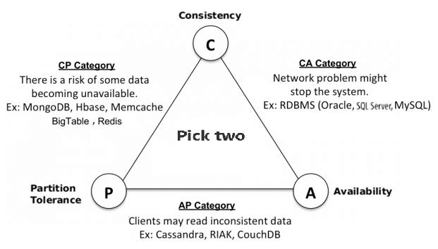So in distributed systems, there is always a tradeoff between C and A (if P is violated = partition will happen)

Resources cited:

https://www.geeksforgeeks.org/the-cap-theorem-in-dbms/